***Student Name: Basavraj Nagappa Jaliminche***

***Student Id: 8800149***

***Date: 8/2/2022***

***PROGRAM: Reporting Systems and Database Development (1517)***

***Course Name: Relational Databases PROG 8590***

***Assignment No: 02***

***Assignment No: 02***

**Question 1. Query full names (Title, First name, middle name and last name) and email address for all persons. (You need to manage NULL values while concatenating the name parts). (use tables Person.Person & Person.EmailAddress)**

**Query**:

SET CONCAT_NULL_YIELDS_NULL OFF --MANAGING NULL VALUES

SELECT [Title]+' '+ [FirstName]+ ' ' + [MiddleName] +' '+

[LastName] AS 'Full Name', E.[EmailAddress] AS 'Email Address' --SELECTING THE ROWS TO PRINT

FROM [Person].[Person] P JOIN [Person].[EmailAddress] E --JOINING THE TWO TABBLES

ON P.BusinessEntityID = E.BusinessEntityID --CREATING LINK BETWWEN TWO TABLES

**Description:**

* We have to use two tables as Person.Person and Person.EmailAddress .
* For displaying results we will take Title , FirstName ,MiddleName and concat them also we have to manage the null values .for that we have to use the ‘SET CONCAT_NULL_YIELDS_NULL OFF’.
* Also we add EmailAddress
* We join the two tables through inner join and link between the two tables is BusinessEntityID.

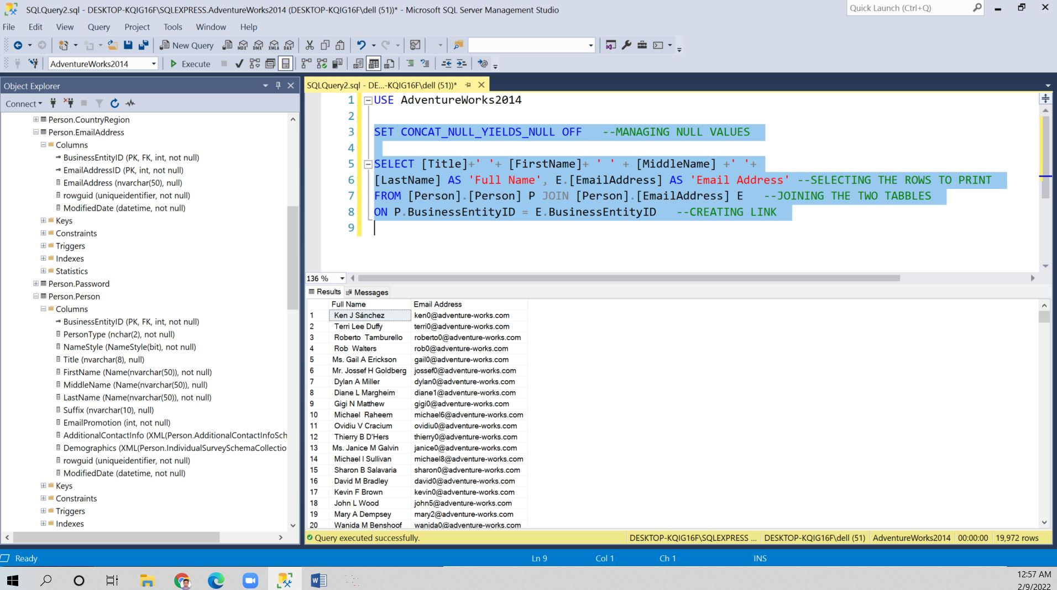

**Question 2. Query the products that are NOT in the Inventory. Use alias for the tables.**

**Query**:

SELECT P.[ProductID] as 'Product ID',[Name] AS 'Product Name' --

DISPLYAING THE PRODUCT NAMES

FROM [Production].[Product] P LEFT JOIN [Production].[ProductInventory] I

--- LEFT JOIN

ON P.[ProductID] = I.[ProductID]

WHERE I.ProductID IS NULL --- CONDITION FOR ABSENT PRODUCTS IN INVENTRY

**Description:**

* We have selected je two tables and joined them with left join.
* We have displayed the product id and product name .
* For displaying the products that are not present in the in inventory we used the I.ProductID IS NULL.

Screen shot of the output is shown on next page.

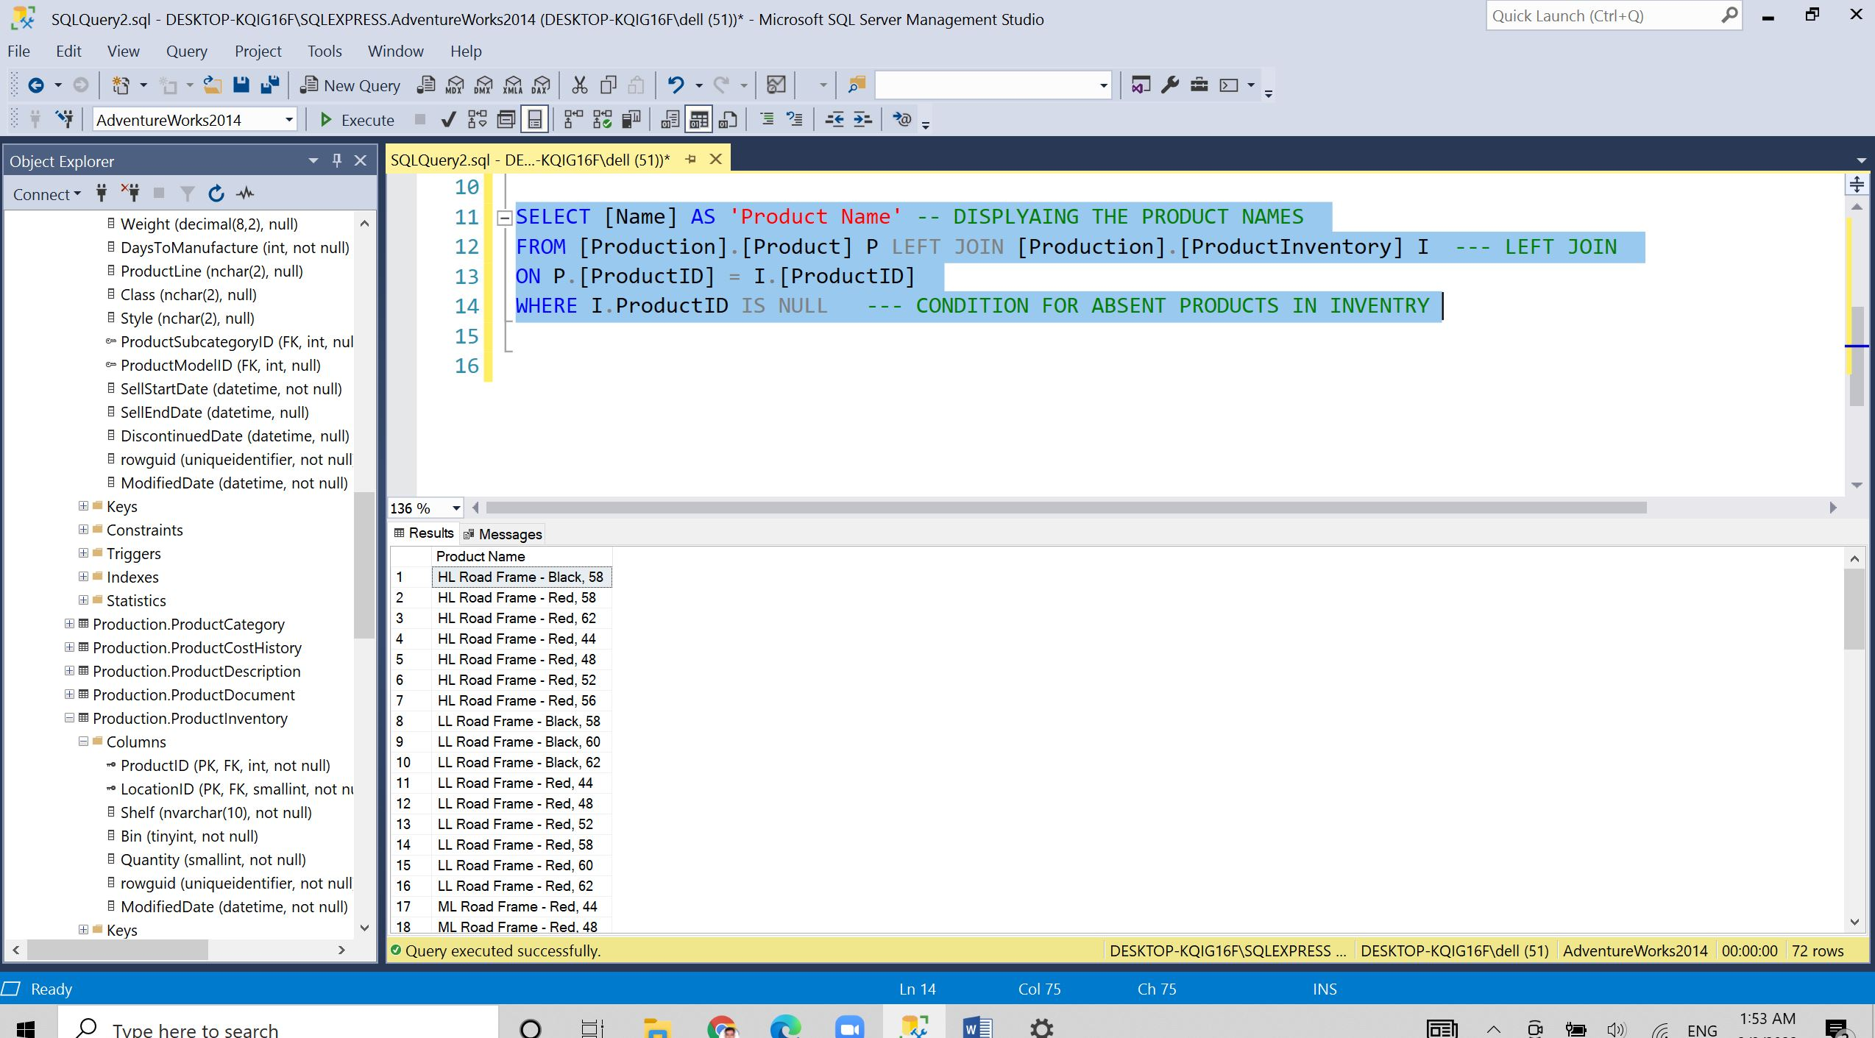

**Question 3. Write a query to show products ( product ID, product name ) with a special offer.**

**Query:**

SELECT DISTINCT P.ProductID AS 'Product ID', P.[Name] AS 'Product Name',S.Description AS 'Spacial Offer'

FROM Production.Product P LEFT JOIN Sales.SpecialOfferProduct SP --USED LEFT JOIN

ON P.ProductID = SP.ProductID INNER JOIN Sales.SpecialOffer S --USED INNER JOIN

ON SP.SpecialOfferID = S.SpecialOfferID

**Description:**

* We have to show products for special offer so we used two tables Production.Product ,Sales.SpacialOffer and Sales.SpecialOfferProduct.
* We have used left join to join the Production.Product and Sales.SpecialOfferProduct .The key is ProductID and made inner join to Sales.SpecialOffer and the key is SpecialOfferID.
* For displaying we have used the ProductID and ProductName .

Screen shot of the output is shown on next page.

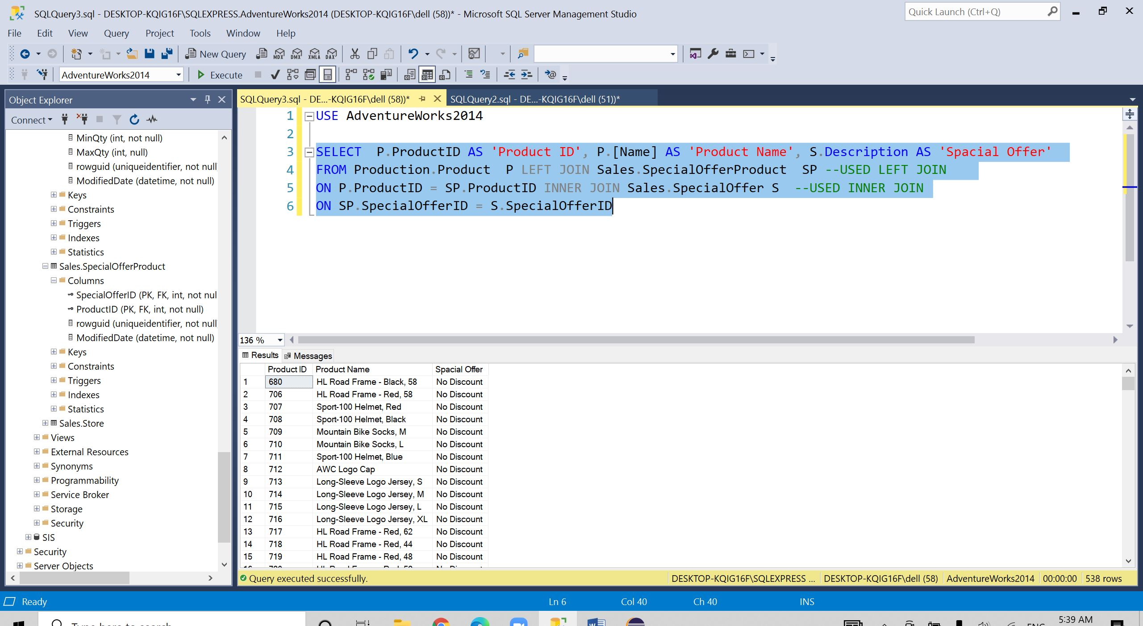

**Question 4. Write a query to show products with same rating.**

**Query :**

SELECTP1.[ProductReviewID],P1.[ProductID],P1.[Rating],P2.[ProductReviewID],P2.[ProductID],P2.[Rating]

FROM [Production].[ProductReview] P1 LEFT JOIN [Production].[ProductReview] P2--join

ON P1.[Rating]= P2.[Rating]---link between the tables

WHERE P1.[ProductID] != P2.[ProductID]--Condition for no dislaying duplicate values

**Description:**

* To show products with same rating we have to make identical table .
* After that we have to join table with the Left Join .
* The link between the table is Rating .
* For not displaying duplicate values we have to give condition as P1.ProductID != P2.ProductID.

Screen shot of the output is shown on next page.

